NAME- VAISHNAVI K
USN-1NT19IS195
BATCH-C3

use vaishnavi_employeedb
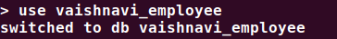

1)Inserting the records
var data=[
{
"id": 1,
"name": "vaishnavi",
"mname": "k",
"lname": "konduru",
"age": 18,
"sal": 25000,
"designation": "PR",
"role": "manager"
},
{
"id": 2,
"name": "padma",
"mname": "m",
"lname": "konduru",
"age": 28,
"sal": 55000,
"designation": "EA",
"role": "UI developer"
},
{
"id": 3,
"name": "prateek",
"mname": "k",
"lname": "konduru",
"age": 38,
"sal": 95000,
"designation": "AC",
"role": "UX developer"
},
{
"id": 4,
"name": "nagesh",
"mname": "rao",
"lname": "konduru",
"age": 48,
"sal": 45000,
"designation": "HR",
"role": "Team lead"
},
{
"id": 5,
"name": "tejaal",
"mname": "rao",
"lname": "mupalla",
"age": 38,
"sal": 25000,
"designation": "ED",
"role": "Manager"
},
{
"id": 6,
"name": "diya",
"mname": "d",
"lname": "mupalla",
"age": 38,
"sal": 25000,
"designation": "AC",
"role": "Associate Manager"
},
{
"id": 7,
"name": "madhavi",
"mname": "m",
"lname": "sai",
"age": 38,
"sal": 5000,
"designation": " AC",
"role": "Accountant"
},
{
"id": 8,
"name": "ramya",
"mname": "d",
"lname": "surya",
"age": 38,
"sal": 95000,
"designation": "PR",
"role": "Assistant Manager"
},
{
"id": 9,
"name": "Varun",
"mname": "m",
"lname": "sandeep",
"age": 68,
"sal": 150000,
"designation": "Ac",
"role": "CEO"
},
{
"id": 10,
"name": "Sindhu",
"mname": "k",
"lname": "sillava",
"age": 38,
"sal": 15000,
"designation": "EA",
"role": "HR"
},

{
"id": 11,
"name": "Nishitha",
"mname": "k",
"lname": "Raghunath",
"age": 18,
"sal": 75000,
"designation": "AC",
"role": "Electrical engineer"
},
{
"id": 12,
"name": "Abhiram",
"mname": "kr",
"lname": "Sinukunar",
"age": 19,
"sal": 55000,
"designation": "ED",
"role": "R&D head"
},
{
"id": 13,
"name": "Vani",
"mname": "p",
"lname": "Venkatesh",
"age": 58,
"sal": 75000,
"designation": "AC",
"role": "Software engineer"
},
{
"id": 14,
"name": "Meghala",
"mname": "r",
"lname": "Kannan",
"age": 28,
"sal": 107000,
"designation": "EDA",
"role": "Senior manager"
},
{
"id": 15,
"name": "Bharath",
"mname": "Kumar",
"lname": "sai",
"age": 18,
"sal": 75000,
"designation": "AC",
"role": "Manager"
}]
db.Employee.insert(data);
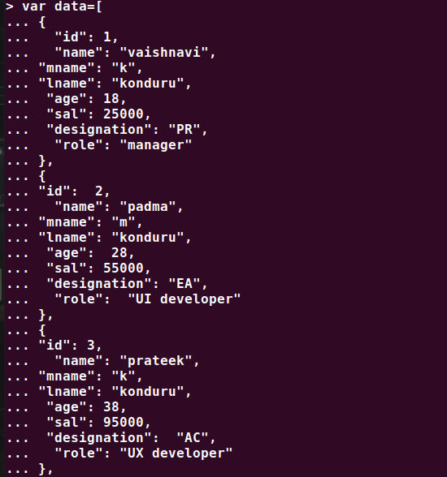

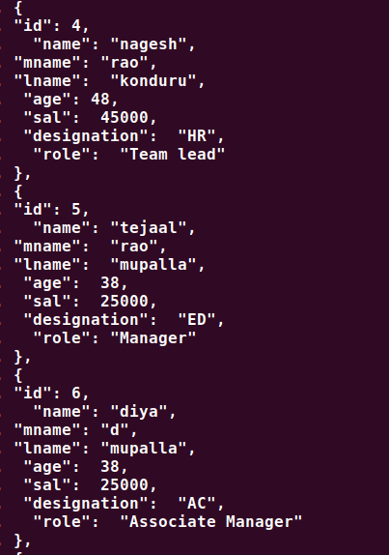

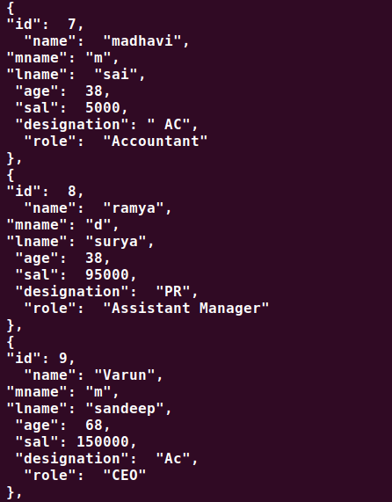

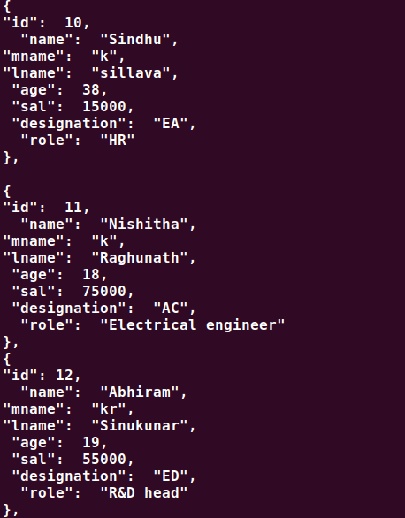

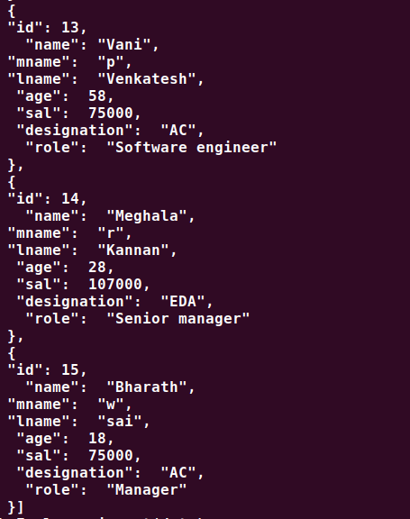

1)Displaying the records
> db.Employee.find().pretty()
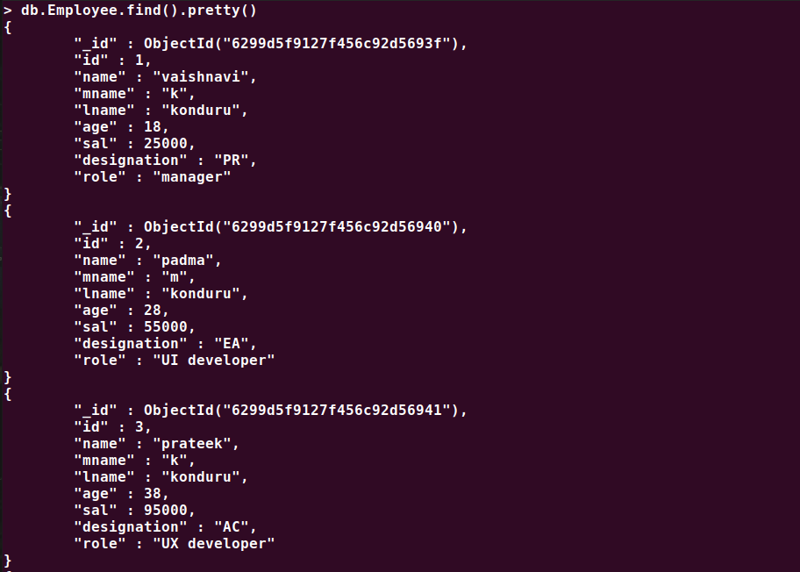
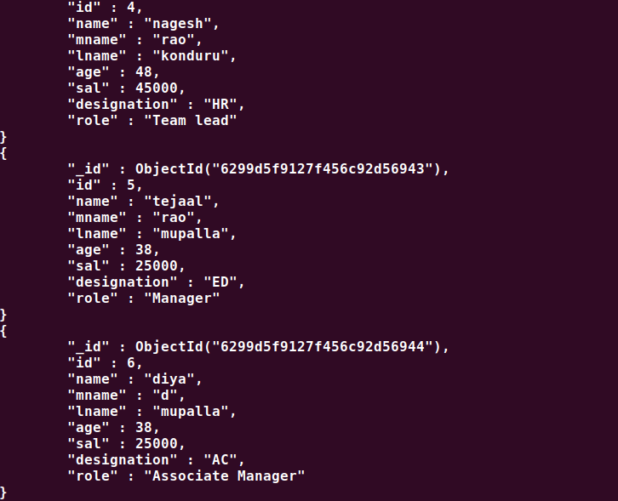

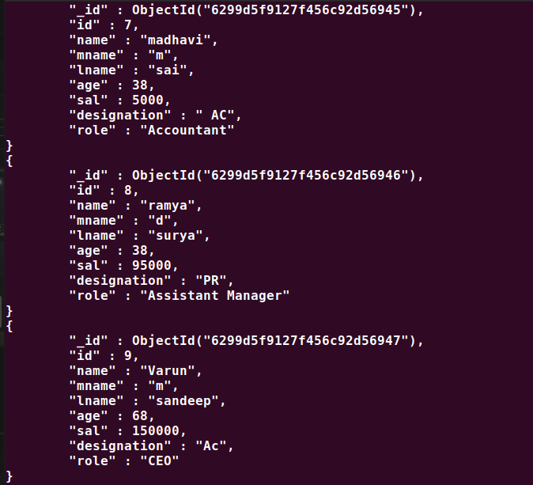

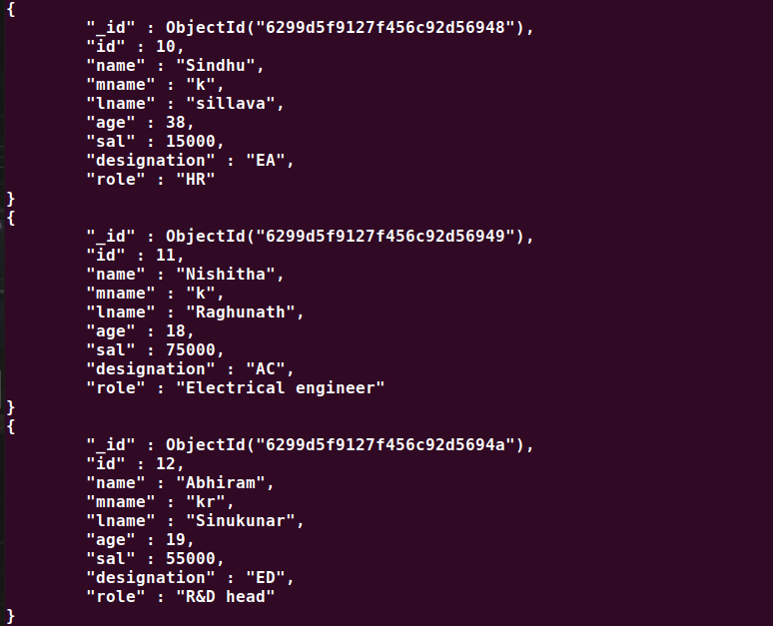
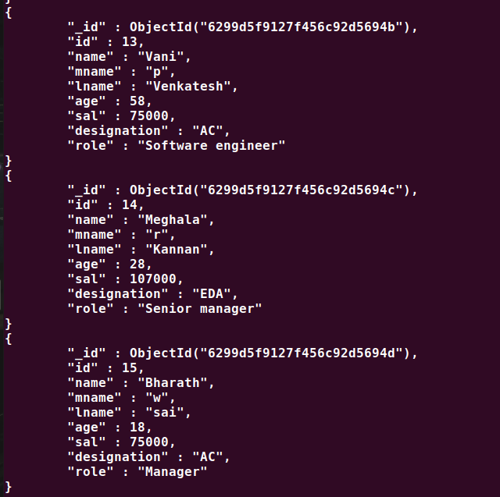
2. List all the records having salary in the range of 20000 – 35000

> db.Employee.find({sal:{$gt:20000,$lt:35000}}).pretty()
db.Employee.find({sal:{$gt:20000,$lt:35000}}).pretty()
{
"_id" : ObjectId("6299d5f9127f456c92d5693f"),
"id" : 1,
"name" : "vaishnavi",
"mname" : "k",
"lname" : "konduru",
"age" : 18,
"sal" : 25000,
"designation" : "PR",
"role" : "manager"
}
{
"_id" : ObjectId("6299d5f9127f456c92d56943"),
"id" : 5,
"name" : "tejaal",
"mname" : "rao",
"lname" : "mupalla",
"age" : 38,
"sal" : 25000,
"designation" : "ED",
"role" : "Manager"
}
{
"_id" : ObjectId("6299d5f9127f456c92d56944"),
"id" : 6,
"name" : "diya",
"mname" : "d",
"lname" : "mupalla",
"age" : 38,
"sal" : 25000,
"designation" : "AC",
"role" : "Associate Manager"
}

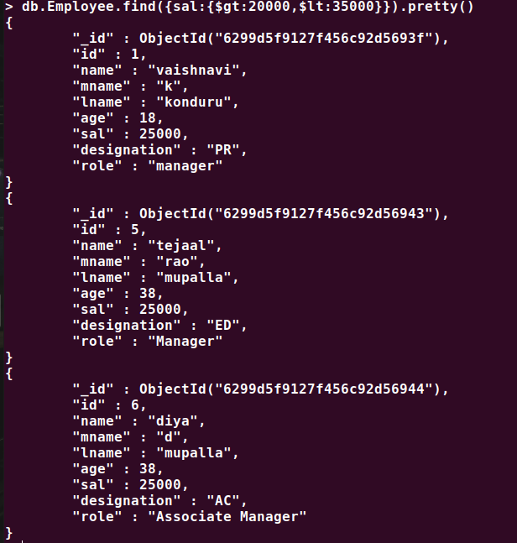

3. List all the Employee whose Middle name is "Rao".

db.Employee.find({"name.mname": "k")

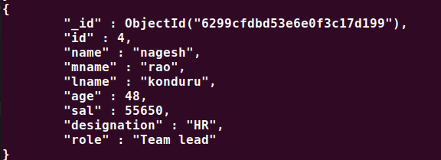

4.Count the number of Employees who has a role "Manager" in the Role field

> db.Employee.find({"role":"Manager"}).count()
2

5.Find out all the documents who have age < 35 and salary in the range of
20000-35000

> db.Employee.find({sal:{$gt:20000,$lt:35000},age:{$lt:35}}).pretty()
{
"_id" : ObjectId("6299d5f9127f456c92d5693f"),
"id" : 1,
"name" : "vaishnavi",
"mname" : "k",
"lname" : "konduru",
"age" : 18,
"sal" : 25000,
"designation" : "PR",
"role" : "manager"
}
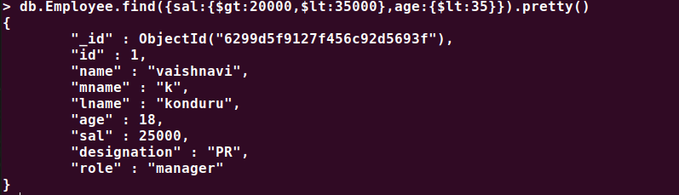

6. Delete an Employee whose "Firstname" is "Varun" and having the
designation as "CEO"

> db.Employee.deleteOne({"name":"Varun"},{"designation":"CEO"})
{ "acknowledged" : true, "deletedCount" : 1 }

7. Update all the Employees whose role is "Team Lead" with a salary of
55650 INR

> db.Employee.updateMany({role:"Team lead"},{$set:{sal:55650}})

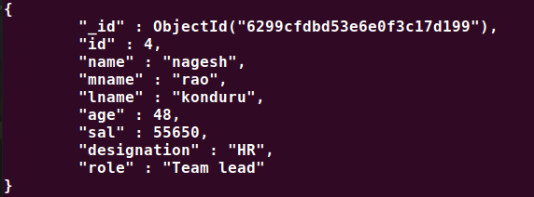

8. Group all the Employees by their age(common age should be there)
and calculate the average salary obtained in the each group
> db.Employee.aggregate([{$group:{_id:"$age",total:{$avg:"$sal"}}}])
{ "_id" : 28, "total" : 81000 }
{ "_id" : 38, "total" : 43333.333333333336 }
{ "_id" : 68, "total" : 150000 }
{ "_id" : 58, "total" : 75000 }
{ "_id" : 18, "total" : 58333.333333333336 }
{ "_id" : 48, "total" : 55650 }
{ "_id" : 19, "total" : 55000 }

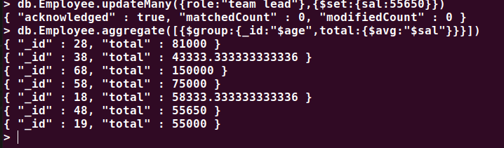

9. Apply the map-reduce to perform the above operation and obtain the results

> var mapfunction=function(){emit(this.age,this.sal)}
> var reducefunction=function(key,values){return Array.avg(values)}
> db.Employee.mapReduce(mapfunction,reducefunction,{'out':'result'})
{ "result" : "result", "ok" : 1 }
> db.result.find()
{ "_id" : 68, "value" : 150000 }
{ "_id" : 38, "value" : 43333.333333333336 }
{ "_id" : 48, "value" : 55650 }
{ "_id" : 18, "value" : 58333.333333333336 }
{ "_id" : 28, "value" : 81000 }
{ "_id" : 19, "value" : 55000 }
{ "_id" : 58, "value" : 75000 }

